Table of Contents
The Go Playground 3
Packages 4
Imports 4
Exported names 4
Functions 5
Multiple results 5
Named return values 5
Variables 6
Variables with initializers 6
Short variable declarations 6
Basic types 7
Zero values 7
Type conversions 7
Type inference 8
Constants 8
Numeric Constants 8
For 11
For is Go's "while" 11
Forever (Infinite Loop) 11
If 12
If with a short statement 12
Switch 13
Switch with no condition 13
Defer 14
Stacking defers 14
Pointers 15
Structs 15
Pointers to structs 15
Struct Literals 16
Arrays 16
Slices 17
Slices are like references to arrays 17
Slice literals 18
Slice defaults 18
Slice length and capacity 19
Nil slices 19
Creating a slice with make 20
Slices of slices 20
Appending to a slice 21
Range 21
Range continued 24
Maps 24
Mutating Maps 25
Function values 25
Function closures 26
Methods 26
Methods are functions 27
Methods continued 27
Pointer receivers 28
Methods and pointer indirection 29
Interfaces 30
Interface values with nil underlying values 31
The empty interface 32
Type assertions 33
Type switches 34
Goroutines 35

Go Lang

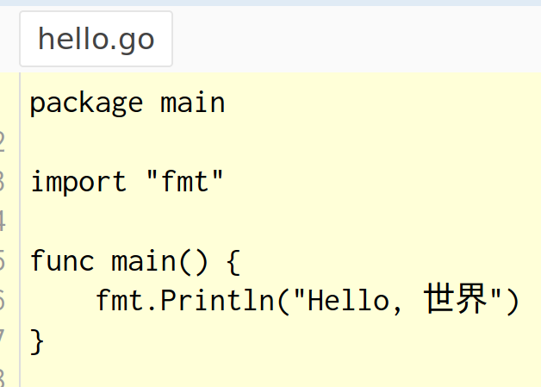

The Go Playground
The service receives a Go program, compiles, links, and runs the program inside a sandbox, then returns the output.

In the playground the time begins at 2009-11-10 23:00:00 UTC (determining the significance of this date is an exercise for the reader). This makes it easier to cache programs by giving them deterministic output.

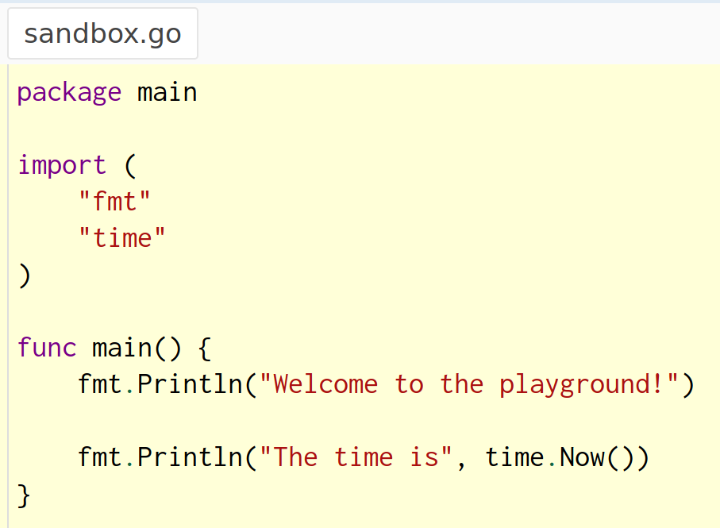
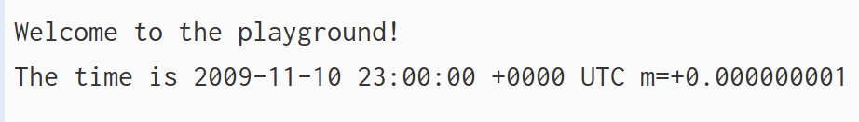

Basics
Packages, variables, and functions.

Packages
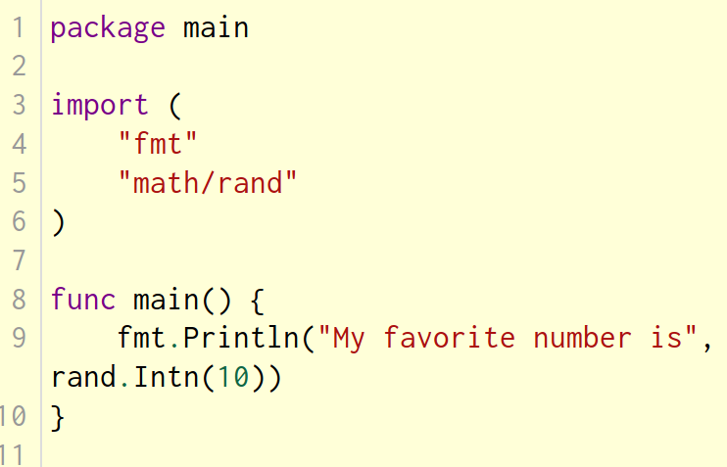
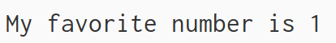

Every Go program is made up of packages. Programs start running in package main. This program is using the packages with import paths "fmt" and "math/rand".
By convention, the package name is the same as the last element of the import path. For instance, the "math/rand" package comprises files that begin with the statement package rand.

Note: The environment in which these programs are executed is deterministic, so each time you run the example program rand.Intn will return the same number.
(To see a different number, seed the number generator; see rand.Seed. Time is constant in the playground, so you will need to use something else as the seed.)

Imports
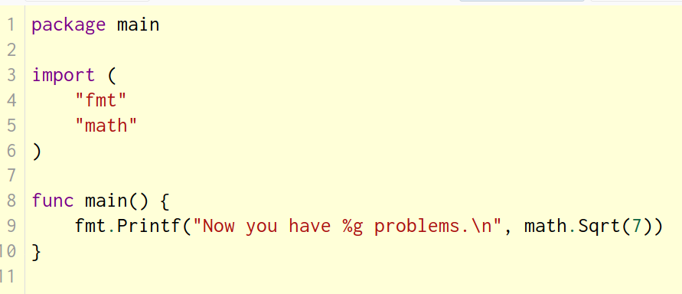
This code groups the imports into a parenthesized, "factored" import statement.
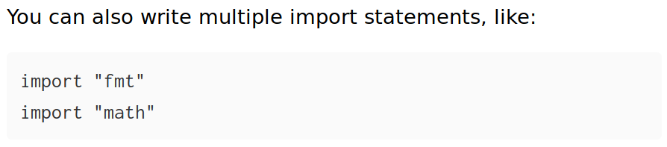

Exported names
In Go, a name is exported if it begins with a capital letter. For example, Pizza is an exported name, as is Pi, which is exported from the math package. When importing a package, you can refer only to its exported names. Any "unexported" names are not accessible from outside the package.
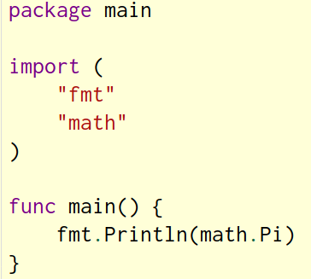
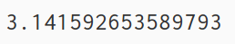

Functions
In this example, add takes two parameters of type int.
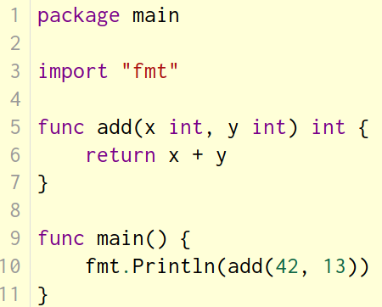

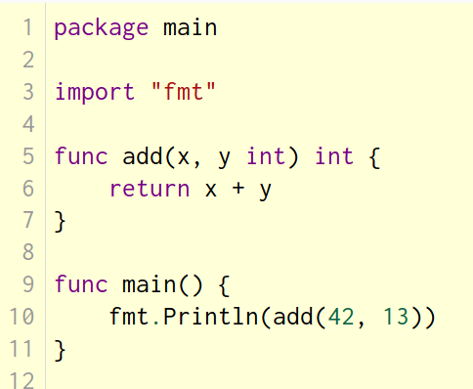
When two or more consecutive named function parameters share a type, you can omit the type from all but the last.
In this example, we shortened
x int, y int
to
x, y int

Multiple results
A function can return any number of results.
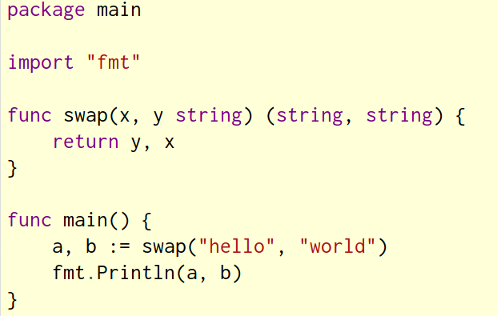

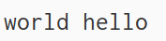

Named return values
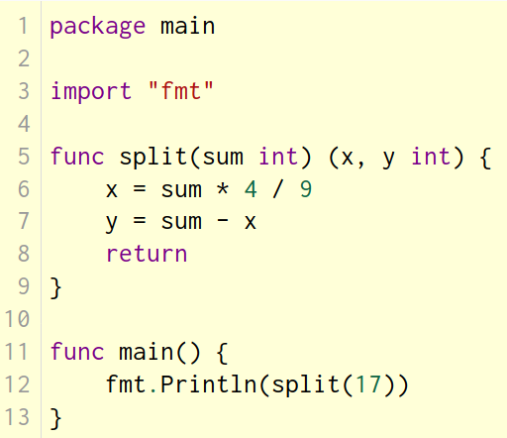
Go's return values may be named. If so, they are treated as variables defined at the top of the function.
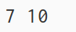

Variables
The var statement declares a list of variables; as in function argument lists, the type is last.
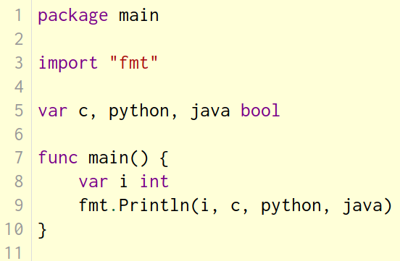
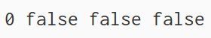

Variables with initializers
A var declaration can include initializers, one per variable. If an initializer is present, the type can be omitted; the variable will take the type of the initializer.
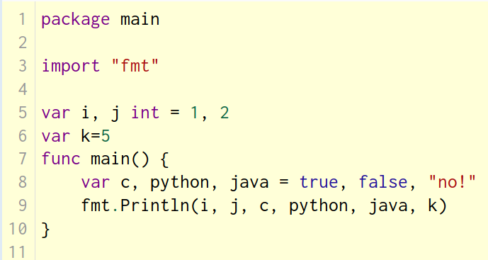
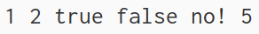

Short variable declarations
Inside a function, the := short assignment statement can be used in place of a var declaration with implicit type. Outside a function, every statement begins with a keyword (var, func, and so on) and so the := construct is not available.
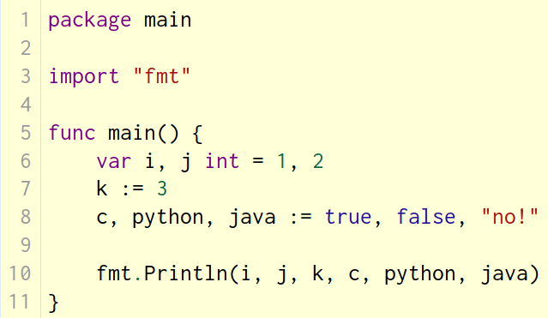
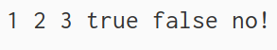

Basic types
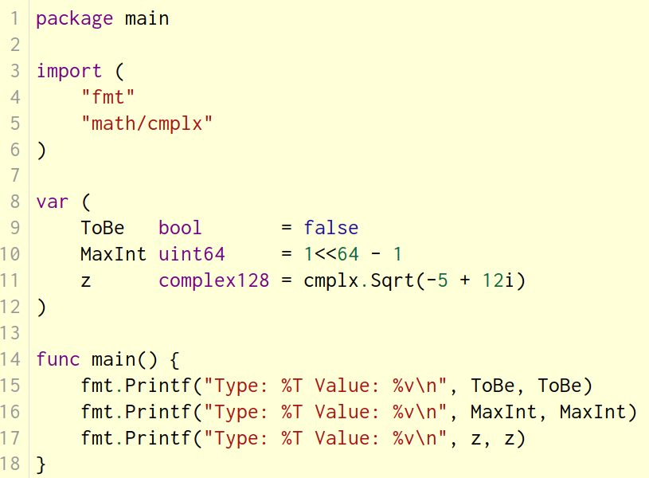
Go's basic types are
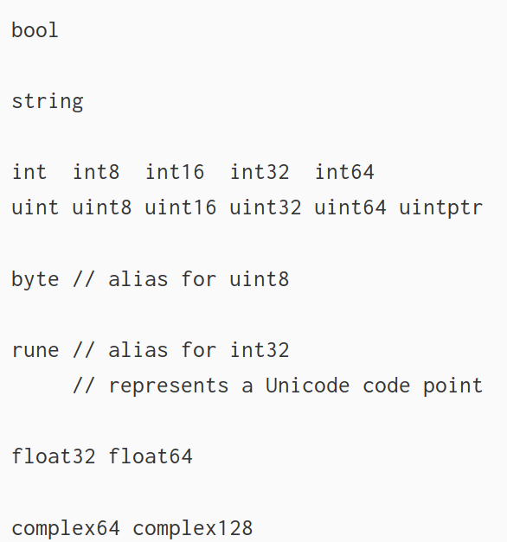
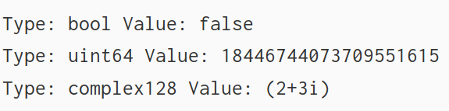

The example shows variables of several types, and also that variable declarations may be "factored" into blocks, as with import statements.
The int, uint, and uintptr types are usually 32 bits wide on 32-bit systems and 64 bits wide on 64-bit systems. When you need an integer value you should use int unless you have a specific reason to use a sized or unsigned integer type.

Zero values
Variables declared without an explicit initial value are given their zero value.
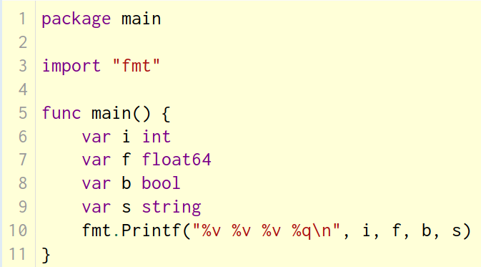
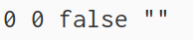
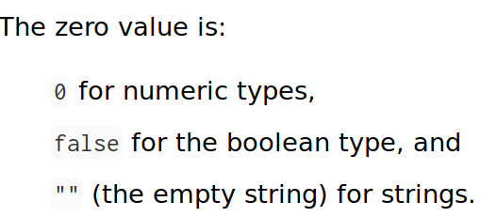

Type conversions
The expression T(v) converts the value v to the type T.
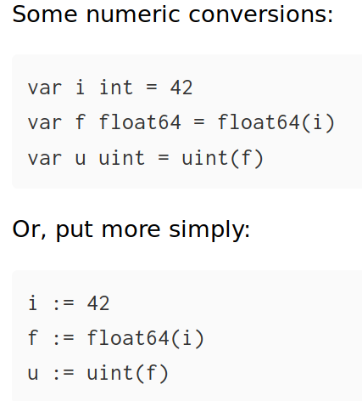
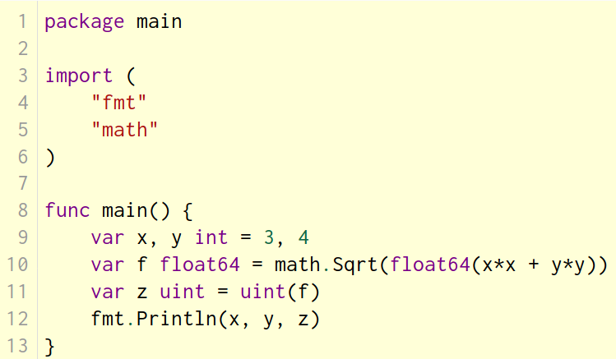
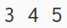

Type inference
When declaring a variable without specifying an explicit type (either by using the := syntax or var = expression syntax), the variable's type is inferred from the value on the right hand side.
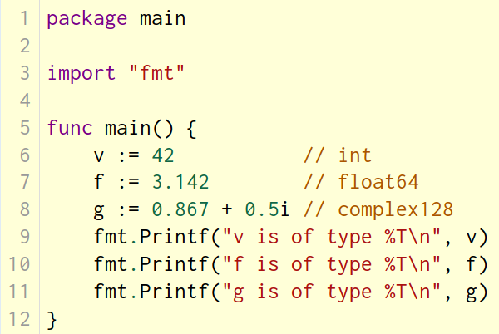
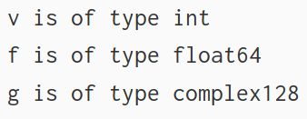

Constants
Constants are declared like variables, but with the const keyword. Constants can be character, string, boolean, or numeric values. Constants cannot be declared using the := syntax.
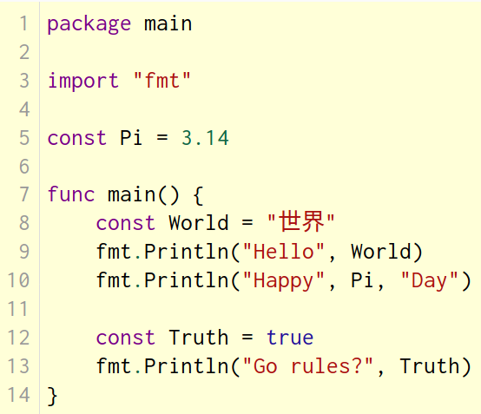
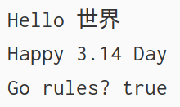

Numeric Constants
Numeric constants are high-precision values. An untyped constant takes the type needed by its context.
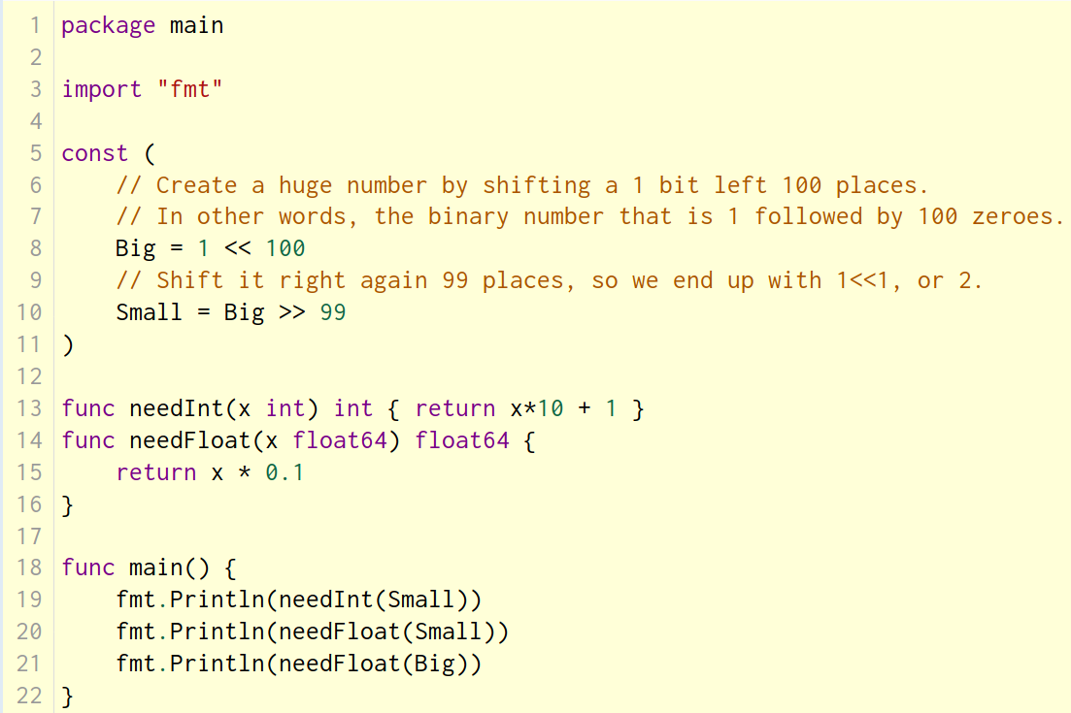

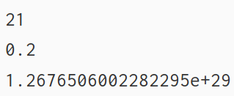
Flow control statements: for, if, else, switch and defer

For
Go has only one looping construct, the for loop.
The basic for loop has three components separated by semicolons:
- the init statement: executed before the first iteration
- the condition expression: evaluated before every iteration
- the post statement: executed at the end of every iteration
The init statement will often be a short variable declaration, and the variables declared there are visible only in the scope of the for statement.
The loop will stop iterating once the boolean condition evaluates to false.
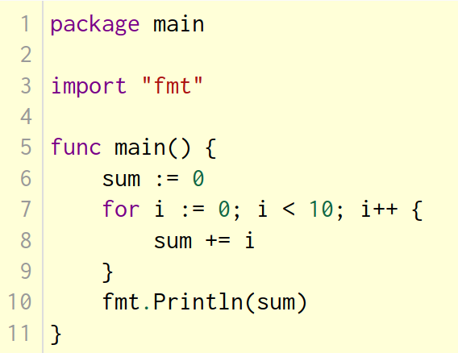
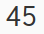

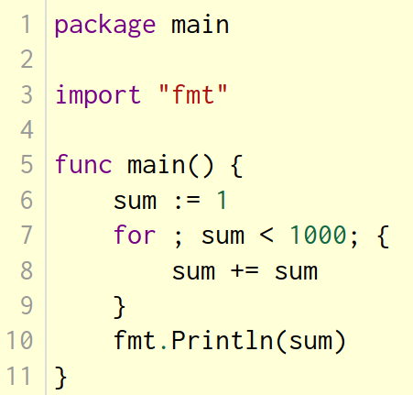
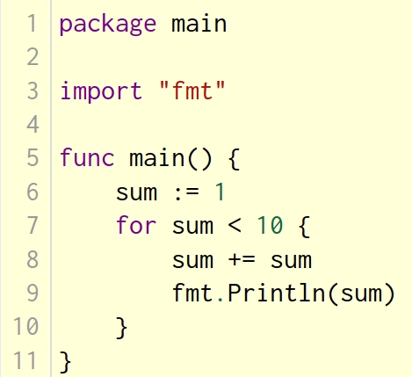
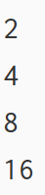

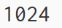

For is Go's "while"
At that point you can drop the semicolons: C's while is spelled for in Go.

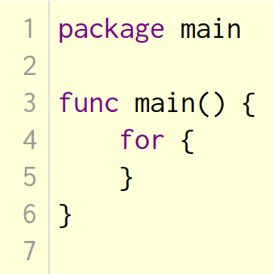
Forever (Infinite Loop)
If you omit the loop condition it loops forever, so an infinite loop is compactly expressed.

If
Go's if statements are like its for loops; the expression need not be surrounded by parentheses ( ) but the braces { } are required.
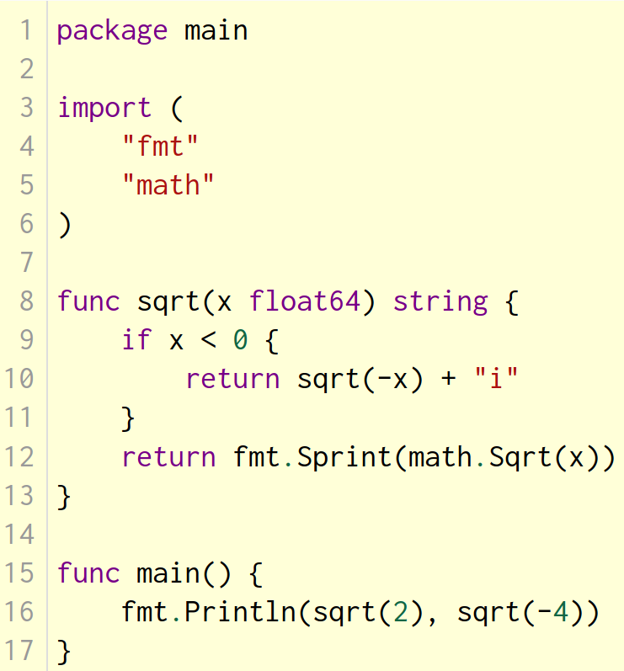
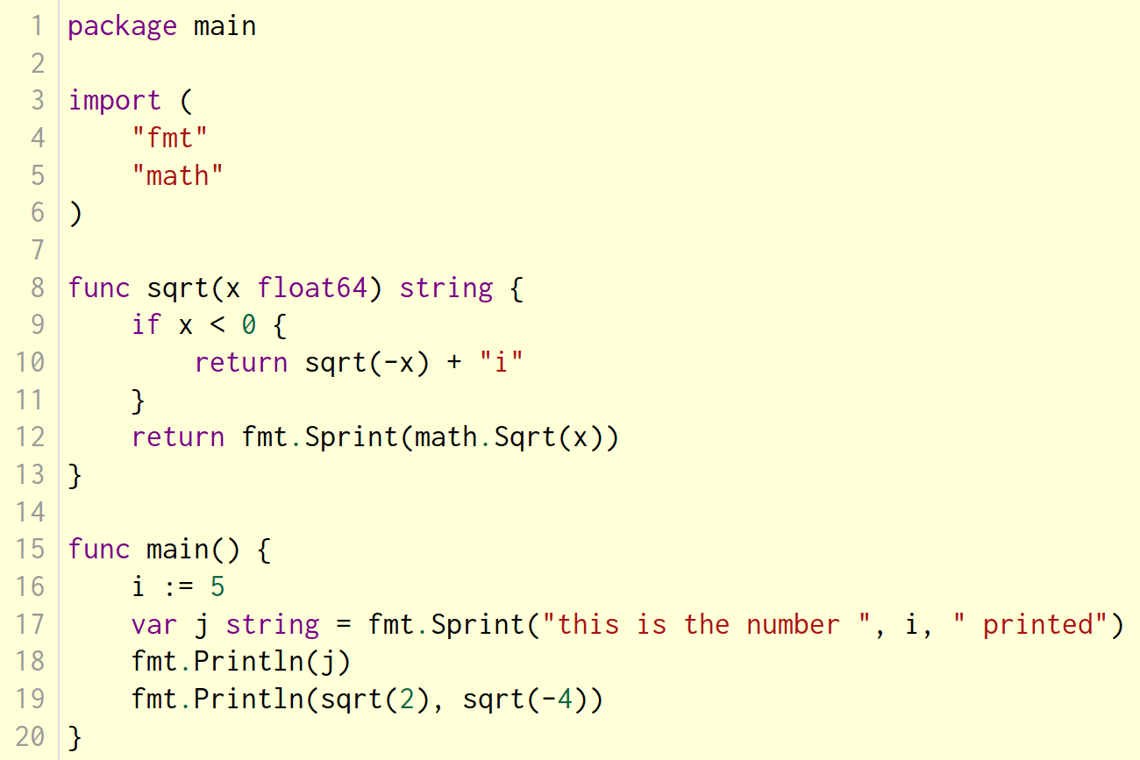
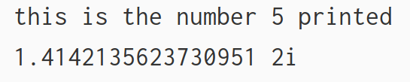
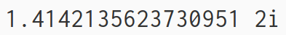

If with a short statement
Like for, the if statement can start with a short statement to execute before the condition. Variables declared by the statement are only in scope until the end of the if.
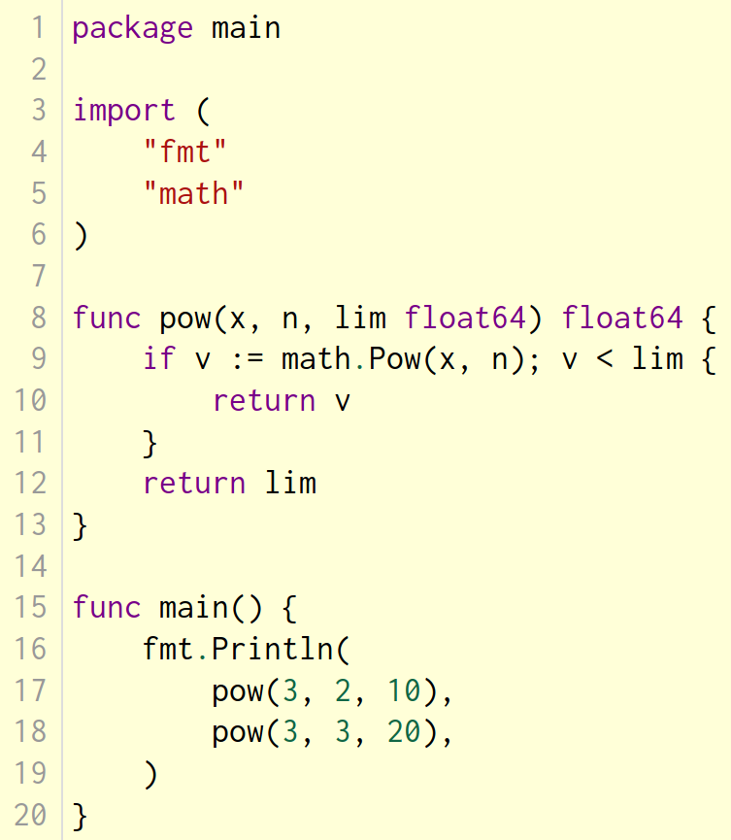
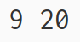
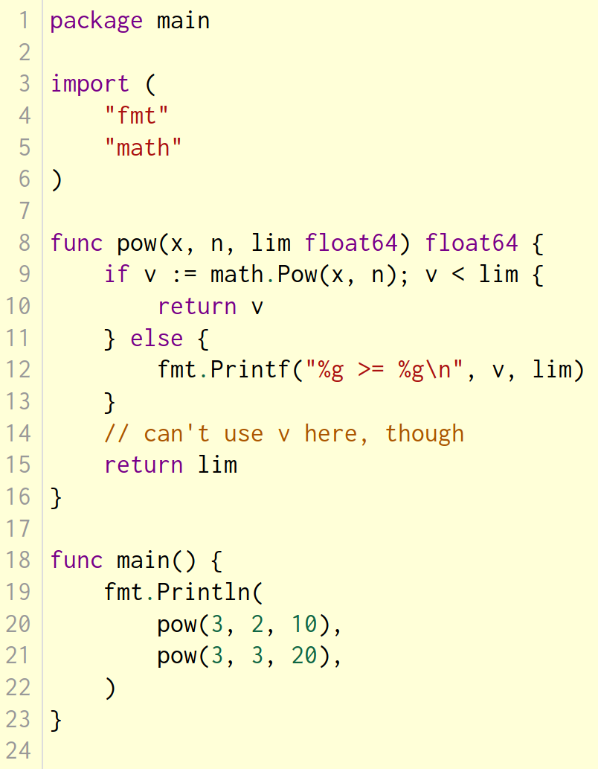
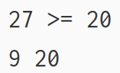


Switch
A switch statement is a shorter way to write a sequence of if - else statements. It runs the first case whose value is equal to the condition expression.
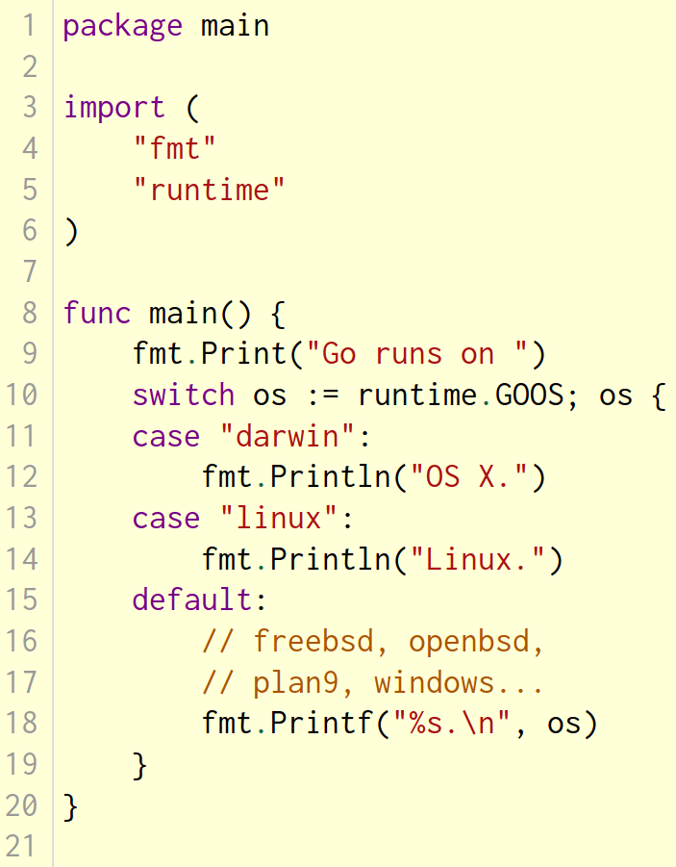
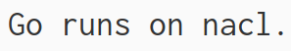

Switch with no condition
Switch without a condition is the same as switch true. This construct can be a clean way to write long if-then-else chains.
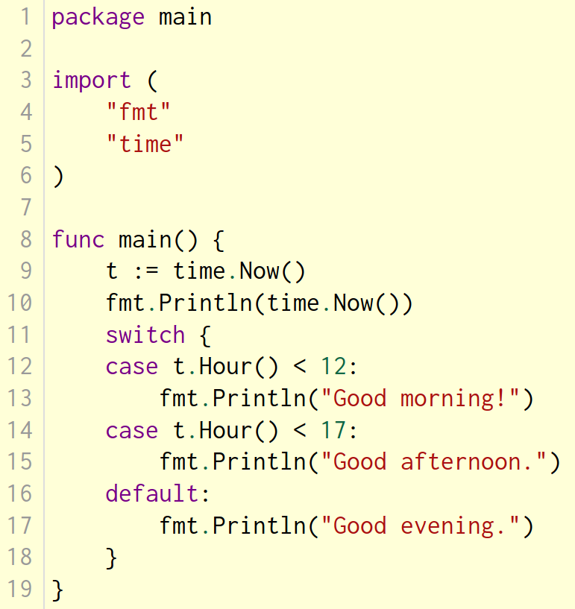
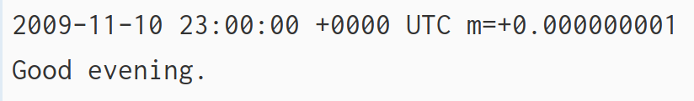

Defer
A defer statement defers the execution of a function until the surrounding function returns. The deferred call's arguments are evaluated immediately, but the function call is not executed until the surrounding function returns.
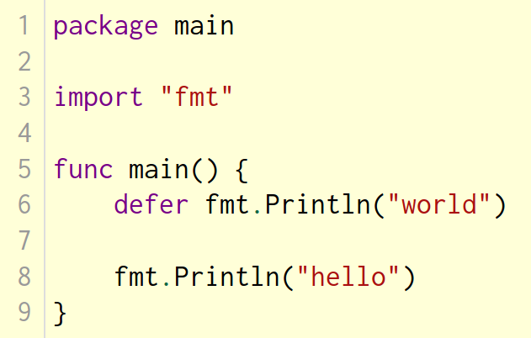
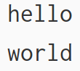

Stacking defers
Deferred function calls are pushed onto a stack. When a function returns, its deferred calls are executed in last-in-first-out order.
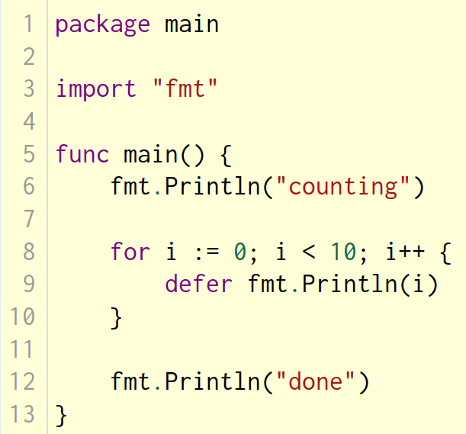
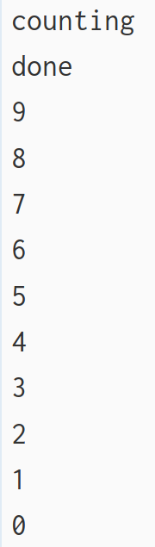
More types: structs, slices, and maps.

Pointers
Go has pointers. A pointer holds the memory address of a value.
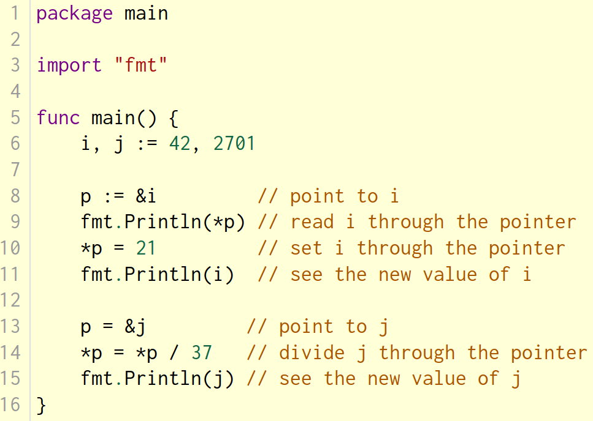
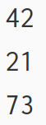

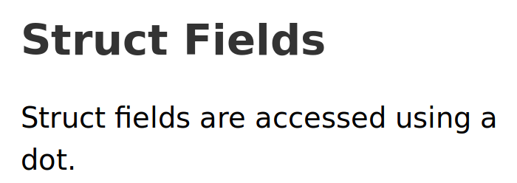
Structs
A struct is a collection of fields.
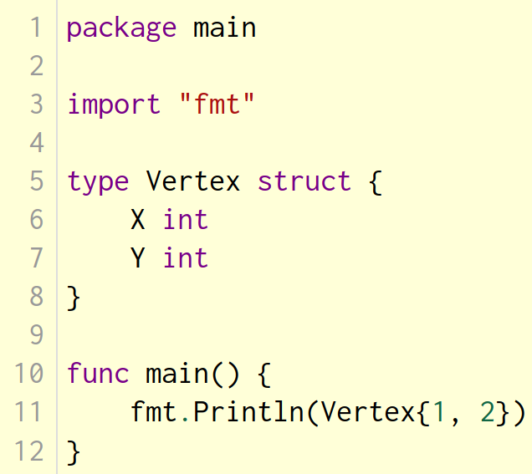
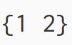
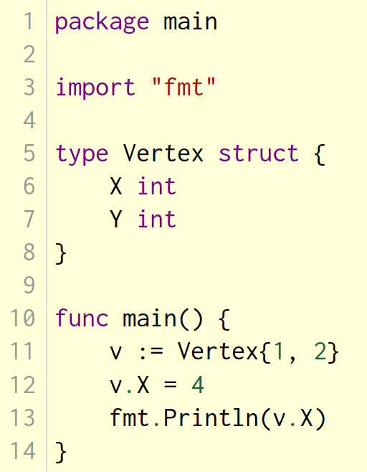
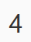

Pointers to structs
Struct fields can be accessed through a struct pointer. To access the field X of a struct when we have the struct pointer p we could write (*p).X. However, that notation is cumbersome, so the language permits us instead to write just p.X, without the explicit dereference.
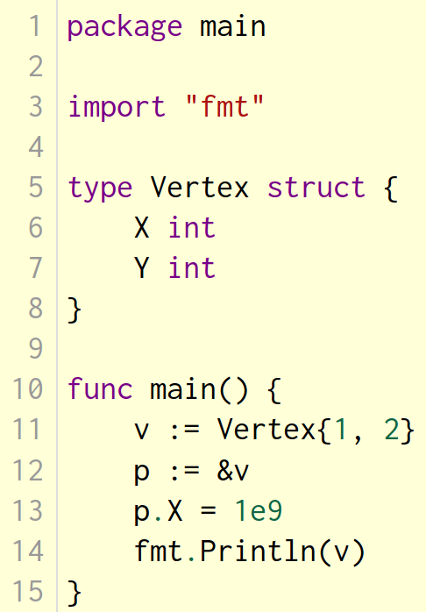
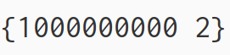

Struct Literals
A struct literal denotes a newly allocated struct value by listing the values of its fields. You can list just a subset of fields by using the Name: syntax. (And the order of named fields is irrelevant.) The special prefix & returns a pointer to the struct value.
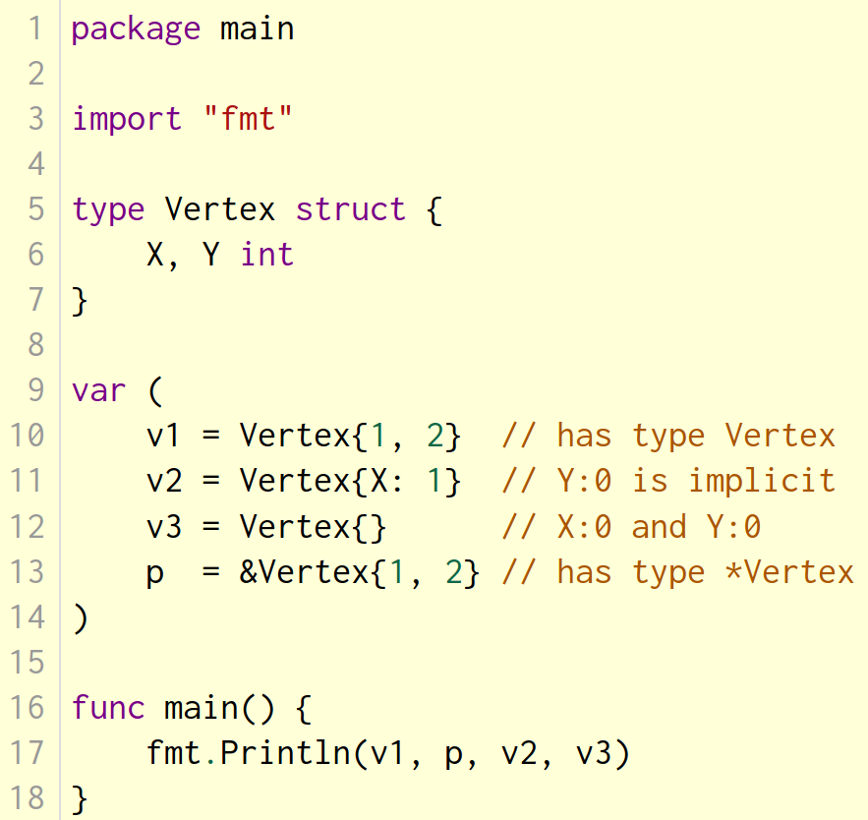
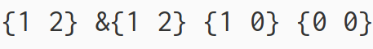

Arrays
The type [n]T is an array of n values of type T.
The expression
var a [10]int
declares a variable a as an array of ten integers.
An array's length is part of its type, so arrays cannot be resized. This seems limiting, but don't worry; Go provides a convenient way of working with arrays.
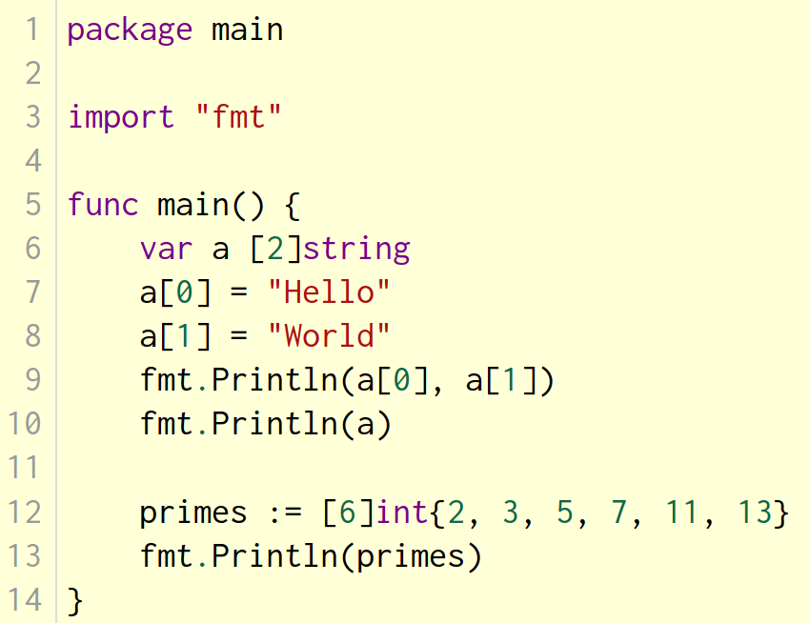
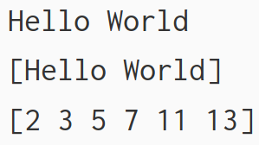

Slices
An array has a fixed size. A slice, on the other hand, is a dynamically-sized, flexible view into the elements of an array. In practice, slices are much more common than arrays.
The type []T is a slice with elements of type T.
A slice is formed by specifying two indices, a low and high bound, separated by a colon:
a[low : high]
This selects a half-open range which includes the first element, but excludes the last one.
The following expression creates a slice which includes elements 1 through 3 of a:
a[1:4]
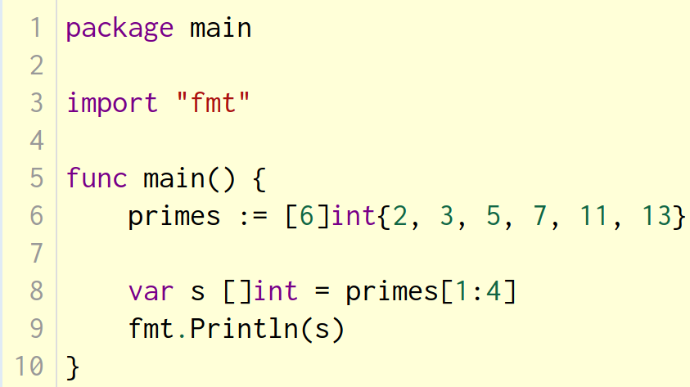
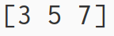

Slices are like references to arrays
A slice does not store any data, it just describes a section of an underlying array. Changing the elements of a slice modifies the corresponding elements of its underlying array. Other slices that share the same underlying array will see those changes.
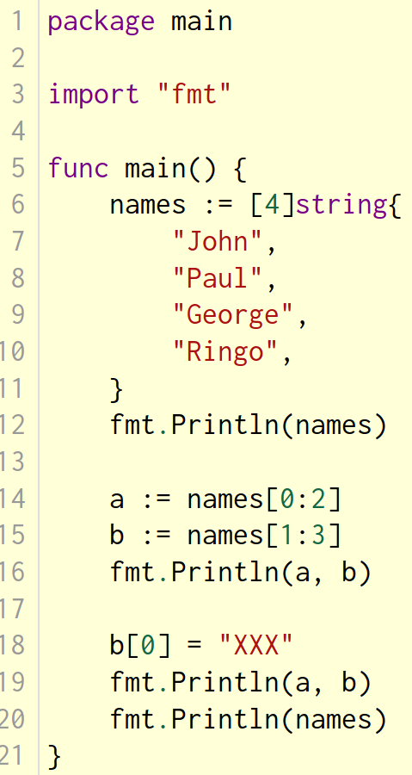
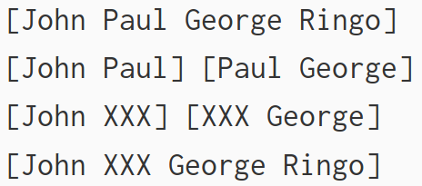

Slice literals
A slice literal is like an array literal without the length.
This is an array literal:
[3]bool{true, true, false}
And this creates the same array as above, then builds a slice that references it:
[]bool{true, true, false}
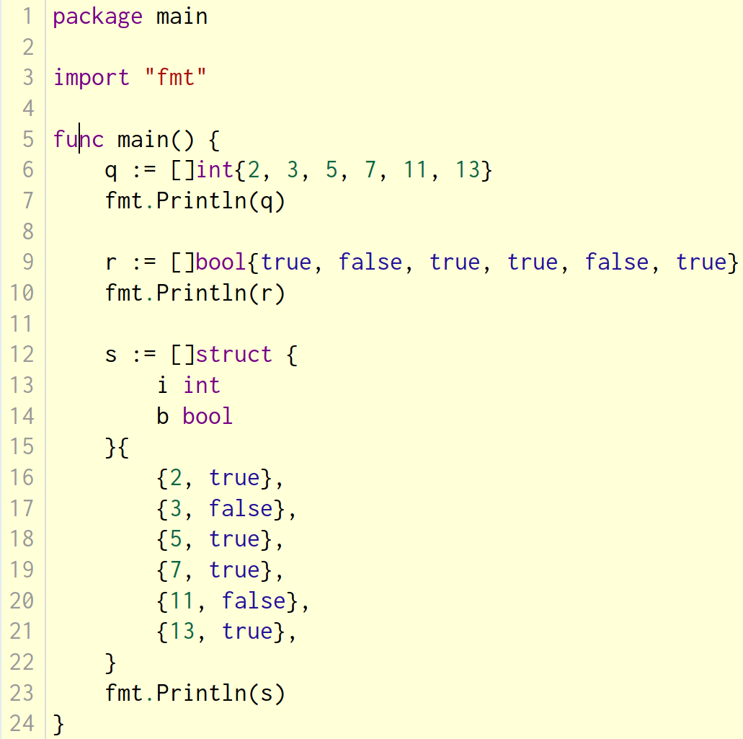
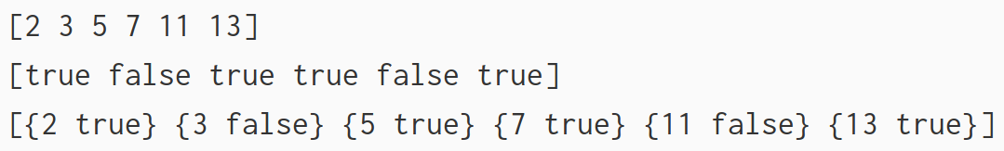

Slice defaults
When slicing, you may omit the high or low bounds to use their defaults instead.
The default is zero for the low bound and the length of the slice for the high bound.
For the array
var a [10]int
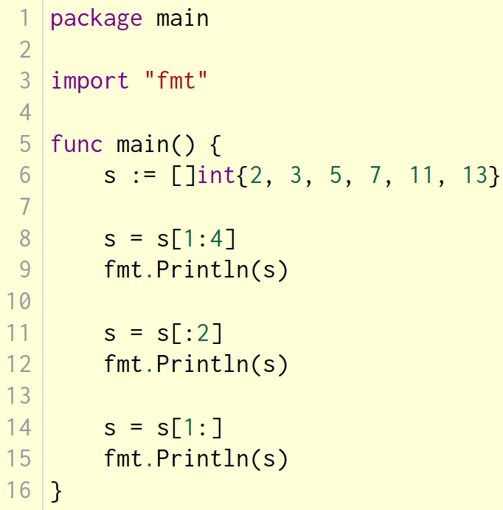
these slice expressions are equivalent:
a[0:10]
a[:10]
a[0:]
a[:]
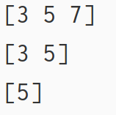

Slice length and capacity
A slice has both a length and a capacity.
The length of a slice is the number of elements it contains.
The capacity of a slice is the number of elements in the underlying array, counting from the first element in the slice.
The length and capacity of a slice s can be obtained using the expressions len(s) and cap(s).
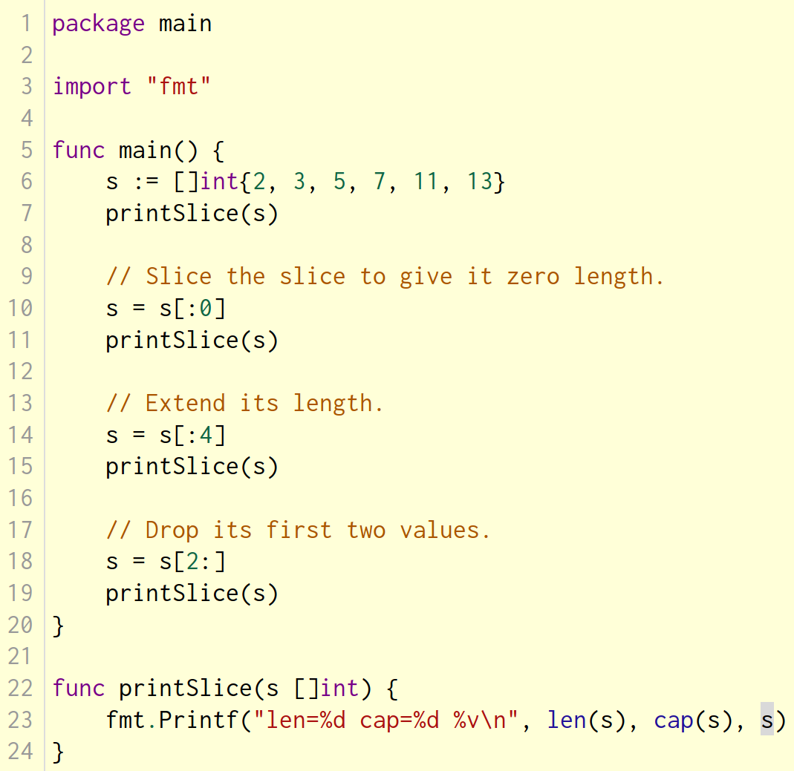
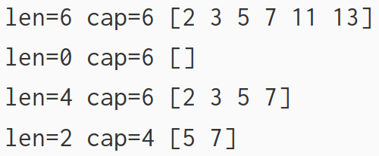

Nil slices
The zero value of a slice is nil.
A nil slice has a length and capacity of 0 and has no underlying array.
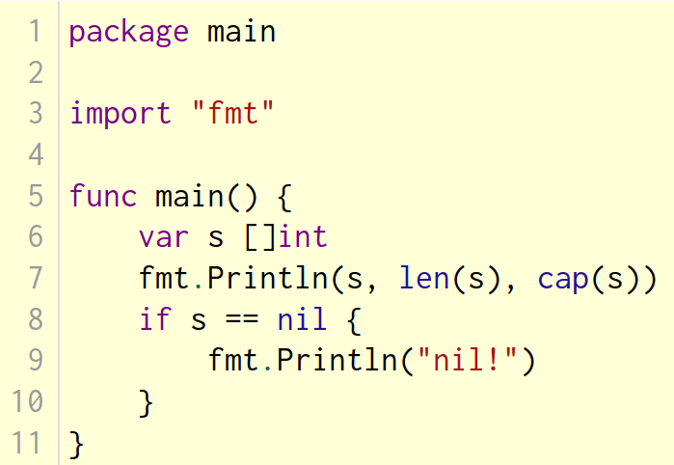
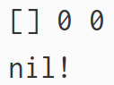

Creating a slice with make
Slices can be created with the built-in make function; this is how you create dynamically-sized arrays.
The make function allocates a zeroed array and returns a slice that refers to that array:
a := make([]int, 5) // len(a)=5
To specify a capacity, pass a third argument to make:
b := make([]int, 0, 5) // len(b)=0, cap(b)=5

b = b[:cap(b)] // len(b)=5, cap(b)=5
b = b[1:] // len(b)=4, cap(b)=4
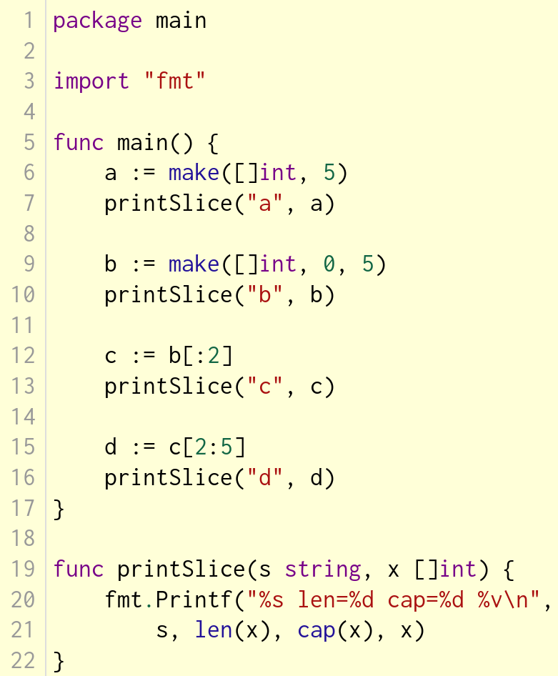

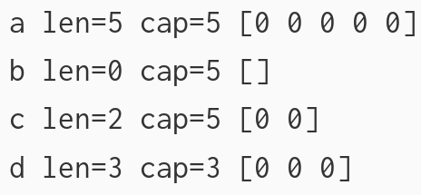

Slices of slices
Slices can contain any type, including other slices.
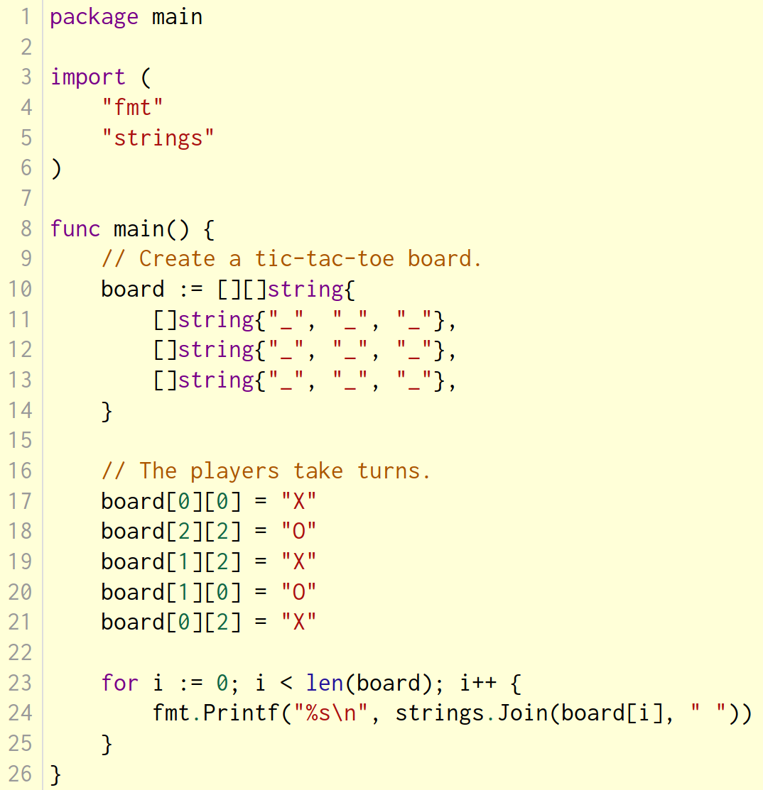
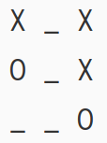

Appending to a slice
It is common to append new elements to a slice, and so Go provides a built-in append function. The documentation of the built-in package describes append.
func append(s []T, vs ...T) []T
The first parameter s of append is a slice of type T, and the rest are T values to append to the slice.
The resulting value of append is a slice containing all the elements of the original slice plus the provided values.
If the backing array of s is too small to fit all the given values a bigger array will be allocated. The returned slice will point to the newly allocated array.
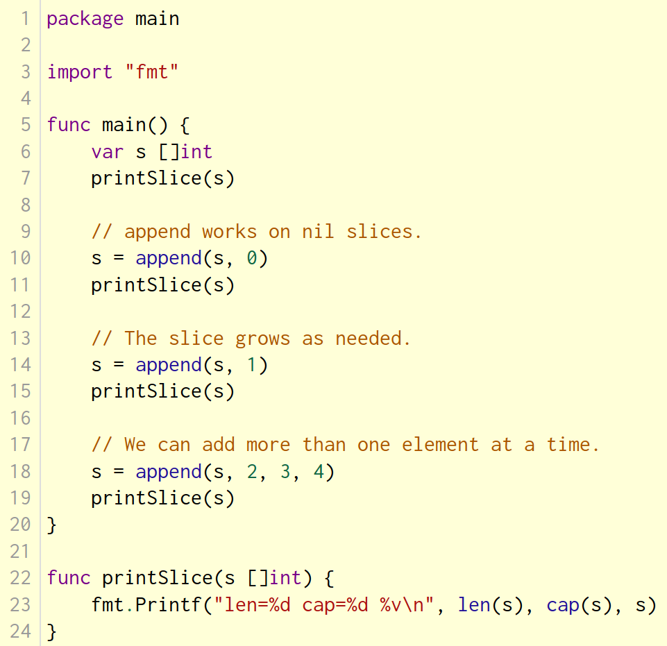
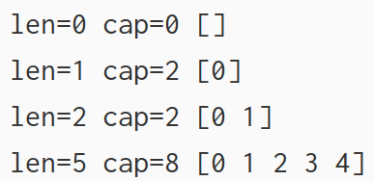

Range
The range form of the for loop iterates over a slice or map.
When ranging over a slice, two values are returned for each iteration. The first is the index, and the second is a copy of the element at that index.
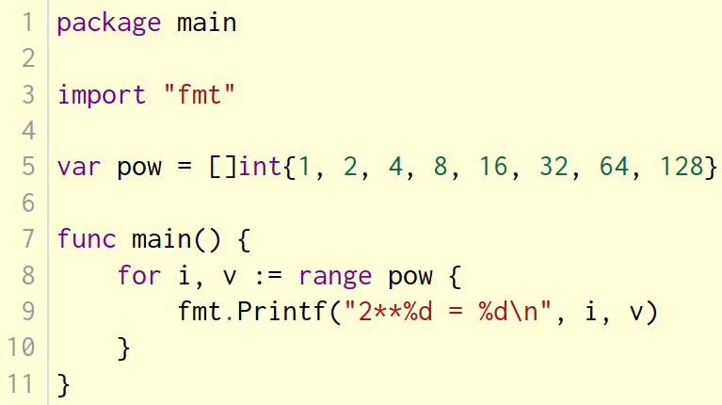
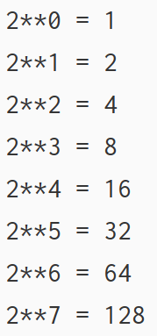

Range continued
You can skip the index or value by assigning to _.
for i, _ := range pow
for _, value := range pow
If you only want the index, you can omit the second variable.
for i := range pow
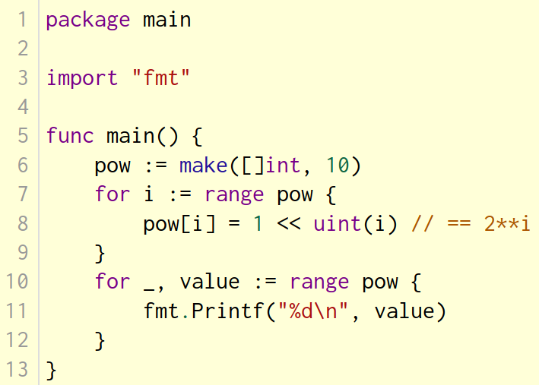
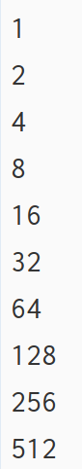

Maps
A map maps keys to values. The zero value of a map is nil. A nil map has no keys, nor can keys be added. The make function returns a map of the given type, initialized and ready for use.
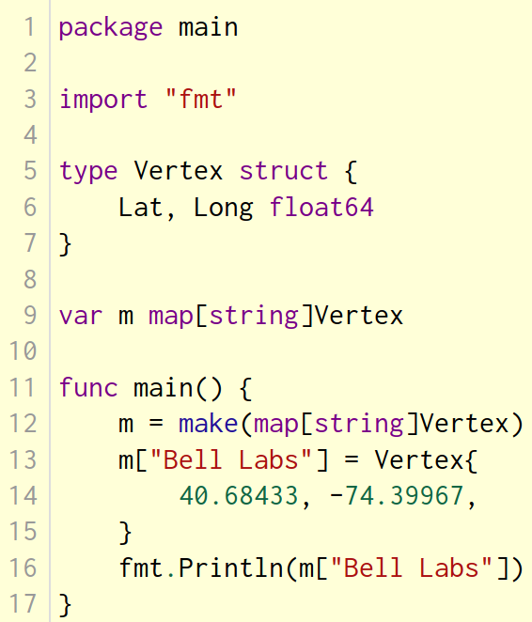
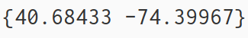
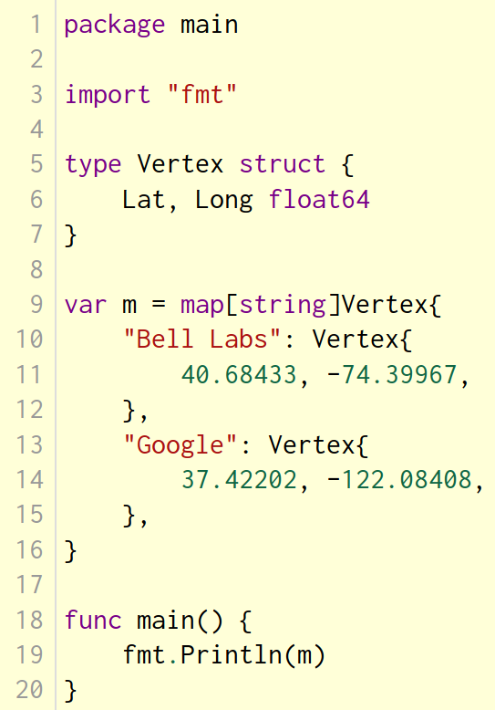
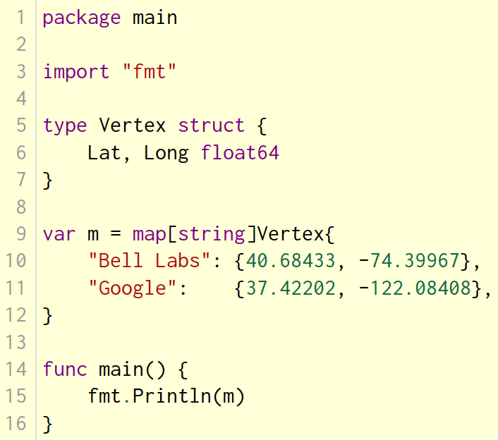

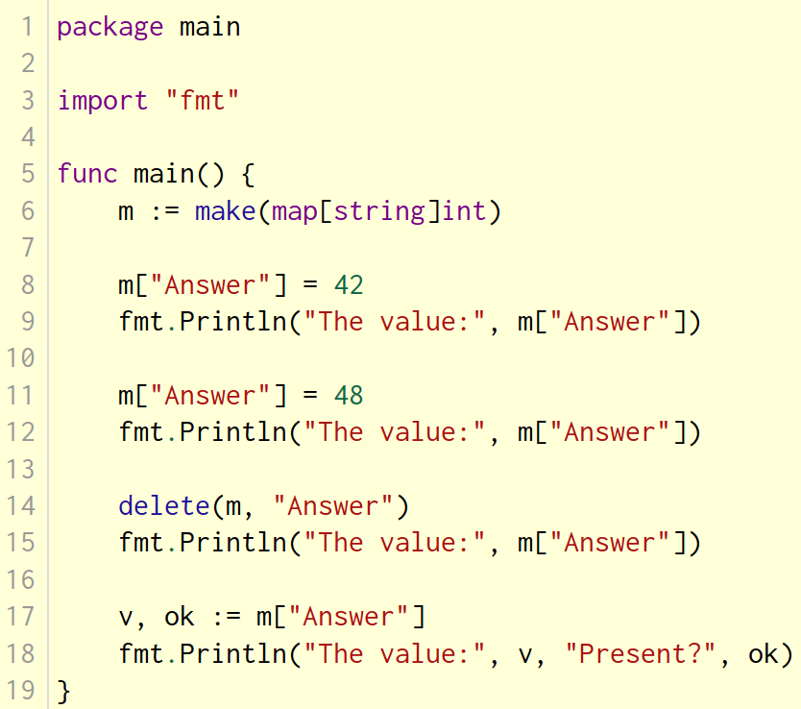
Mutating Maps
Insert or update an element in map m:
m[key] = elem
Retrieve an element:
elem = m[key]
Delete an element:
delete(m, key)
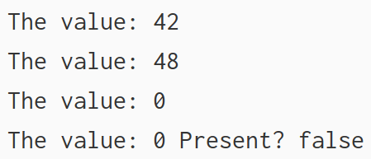
Test that a key is present with a two-value assignment:
elem, ok = m[key]
If key is in m, ok is true. If not, ok is false.
If key is not in the map, then elem is the zero value for the map's element type.
Note: If elem or ok have not yet been declared you could use a short declaration form:
elem, ok := m[key]

Function values
Functions are values too. They can be passed around just like other values. Function values may be used as function arguments and return values.
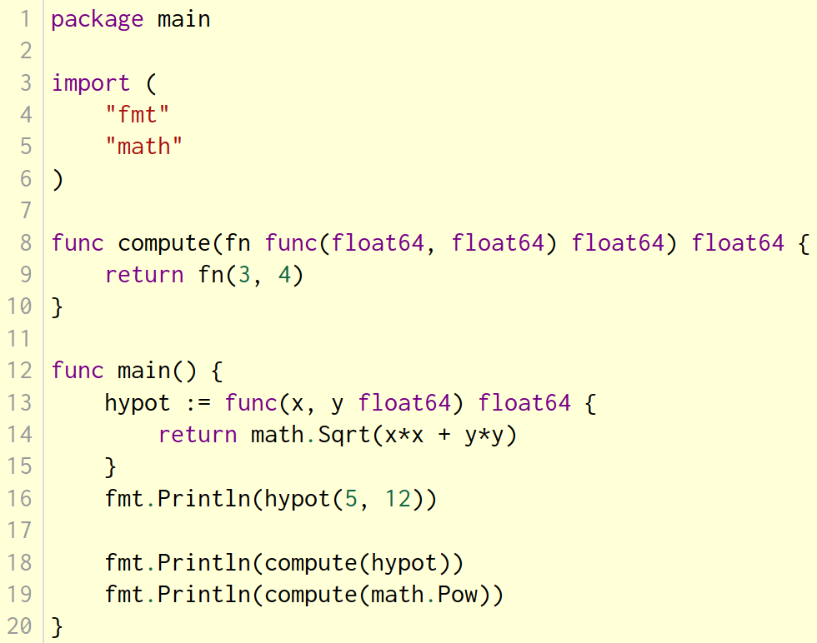
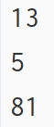

Function closures
Go functions may be closures. A closure is a function value that references variables from outside its body. The function may access and assign to the referenced variables; in this sense the function is "bound" to the variables.
For example, the adder function returns a closure. Each closure is bound to its own sum variable.
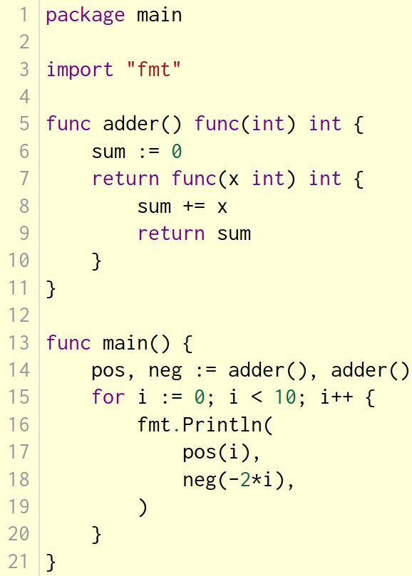
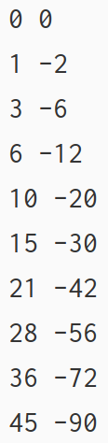

Methods and interfaces

Methods
Go does not have classes. However, you can define methods on types.
A method is a function with a special receiver argument.
The receiver appears in its own argument list between the func keyword and the method name.
In this example, the Abs method has a receiver of type Vertex named v.
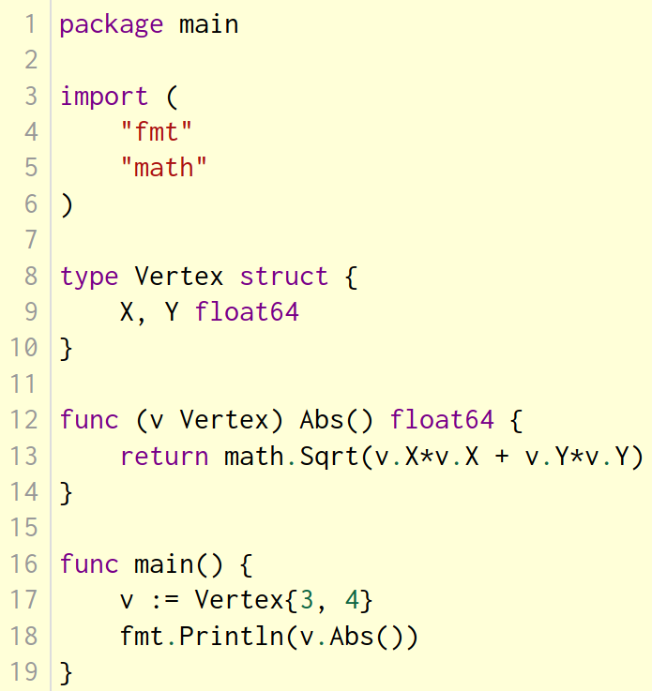
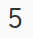

Methods are functions
Remember: a method is just a function with a receiver argument.
Here's Abs written as a regular function with no change in functionality.
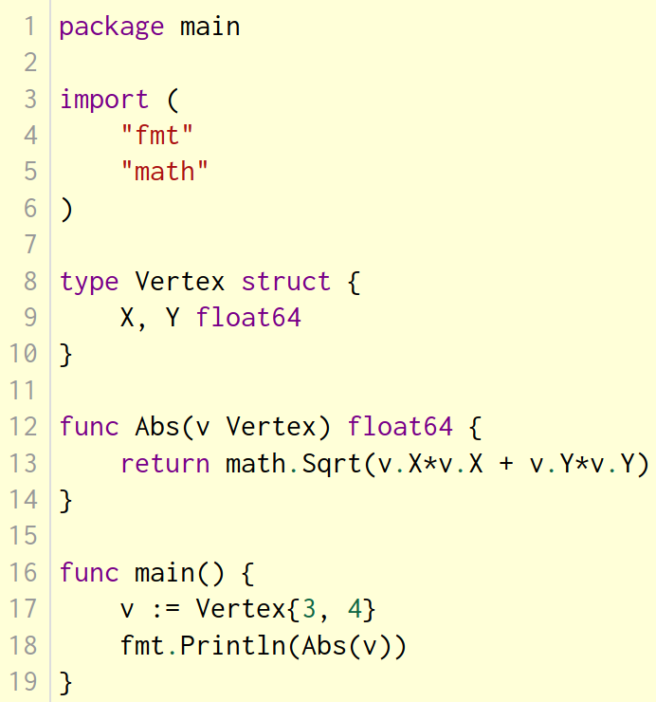

Methods continued
You can declare a method on non-struct types, too.
In this example we see a numeric type MyFloat with an Abs method.
You can only declare a method with a receiver whose type is defined in the same package as the method. You cannot declare a method with a receiver whose type is defined in another package (which includes the built-in types such as int).
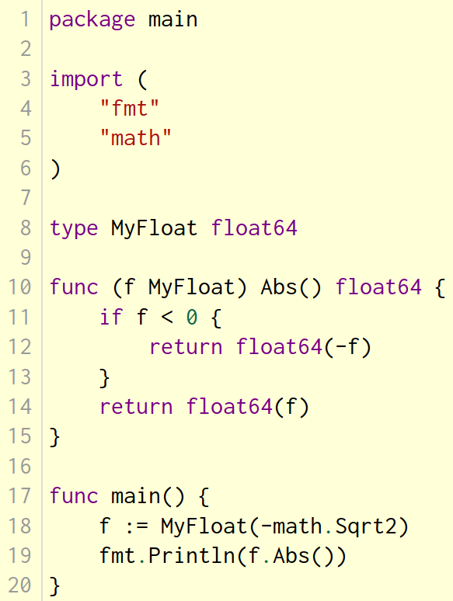
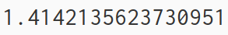

Pointer receivers
You can declare methods with pointer receivers.
This means the receiver type has the literal syntax *T for some type T. (Also, T cannot itself be a pointer such as *int.)
For example, the Scale method here is defined on *Vertex.
Methods with pointer receivers can modify the value to which the receiver points (as Scale does here). Since methods often need to modify their receiver, pointer receivers are more common than value receivers.
Try removing the * from the declaration of the Scale function on line 16 and observe how the program's behavior changes.
With a value receiver, the Scale method operates on a copy of the original Vertex value. (This is the same behavior as for any other function argument.) The Scale method must have a pointer receiver to change the Vertex value declared in the main function.
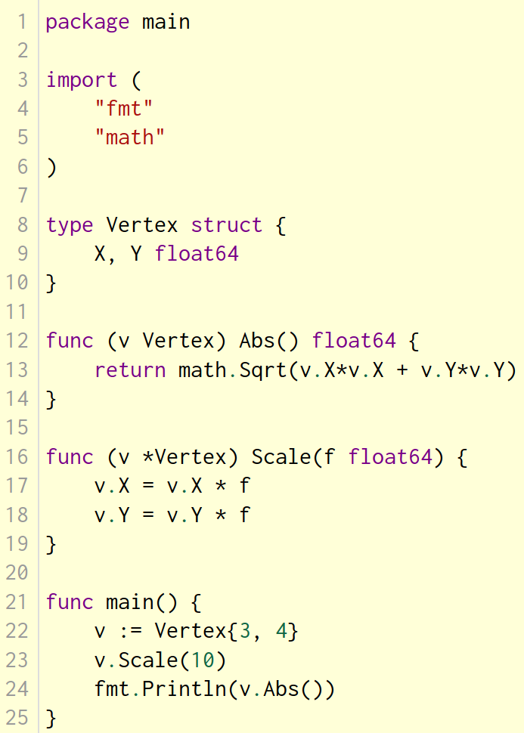
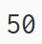
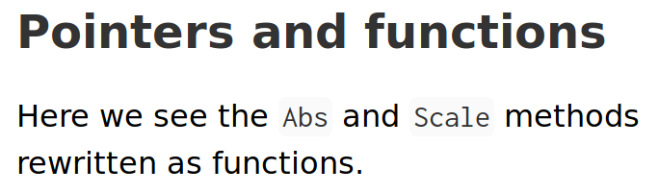
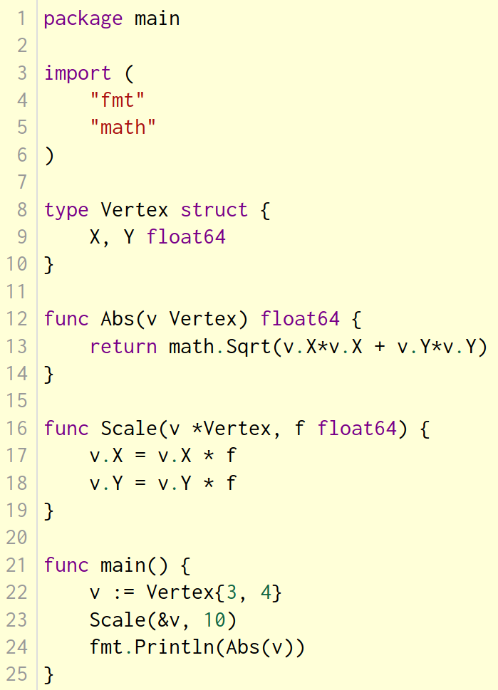
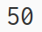

Methods and pointer indirection
Comparing the previous two programs, you might notice that functions with a pointer argument must take a pointer:
var v Vertex
ScaleFunc(v, 5) // Compile error!
ScaleFunc(&v, 5) // OK
while methods with pointer receivers take either a value or a pointer as the receiver when they are called:
var v Vertex
v.Scale(5) // OK
p := &v
p.Scale(10) // OK
For the statement v.Scale(5), even though v is a value and not a pointer, the method with the pointer receiver is called automatically. That is, as a convenience, Go interprets the statement v.Scale(5) as (&v).Scale(5) since the Scale method has a pointer receiver.
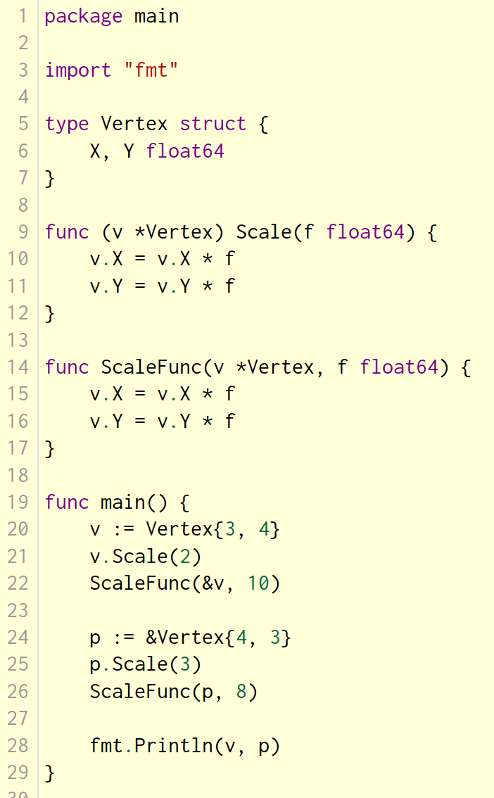
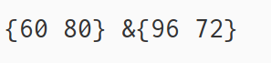
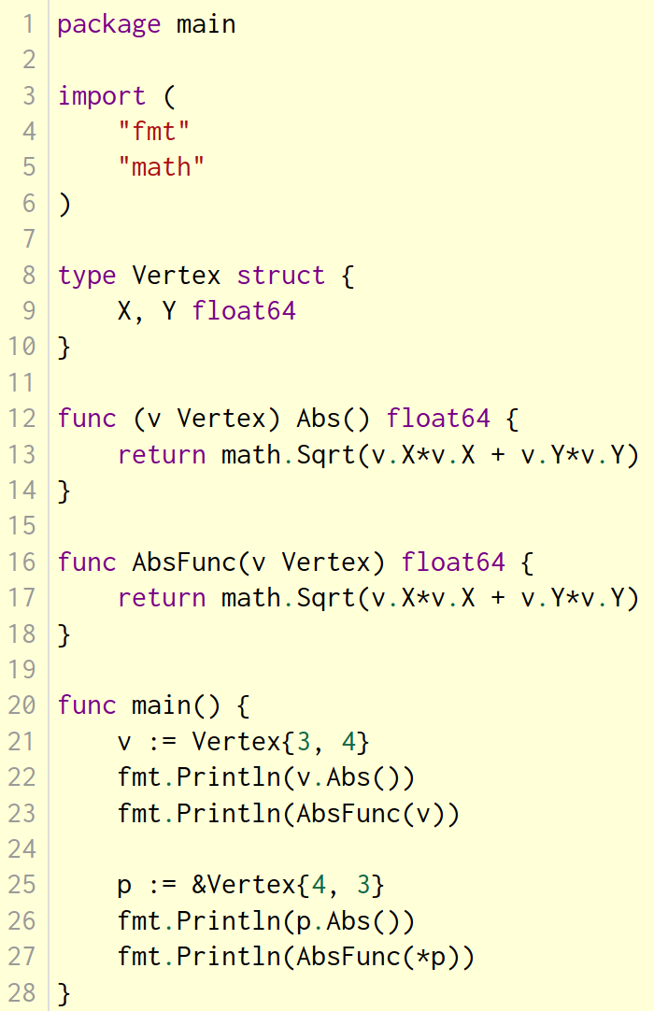
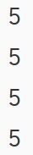
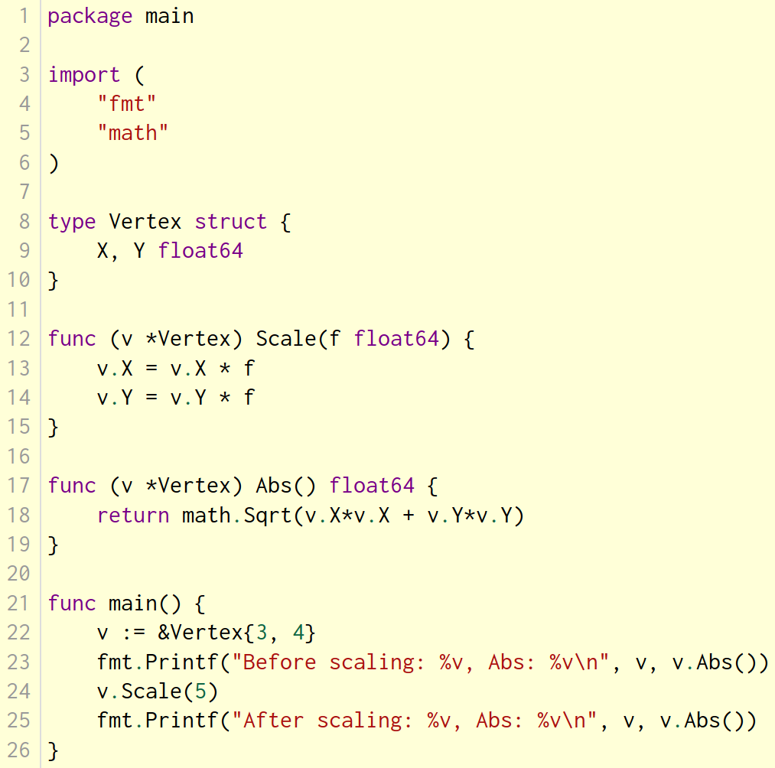
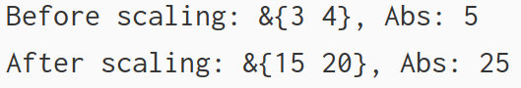

Interfaces
An interface type is defined as a set of method signatures. A value of interface type can hold any value that implements those methods.
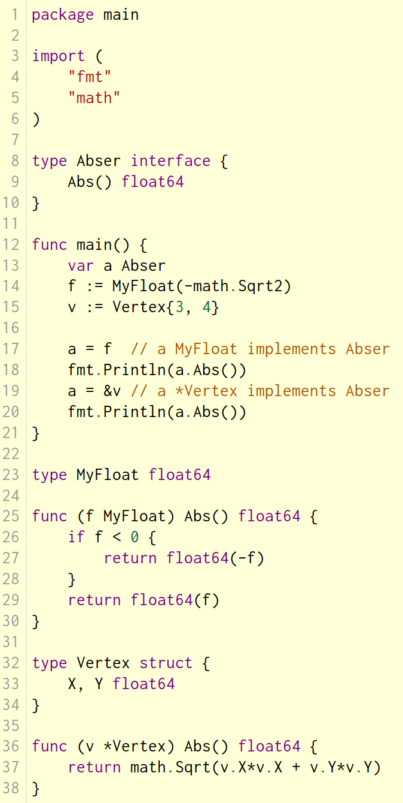
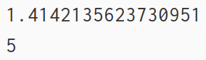
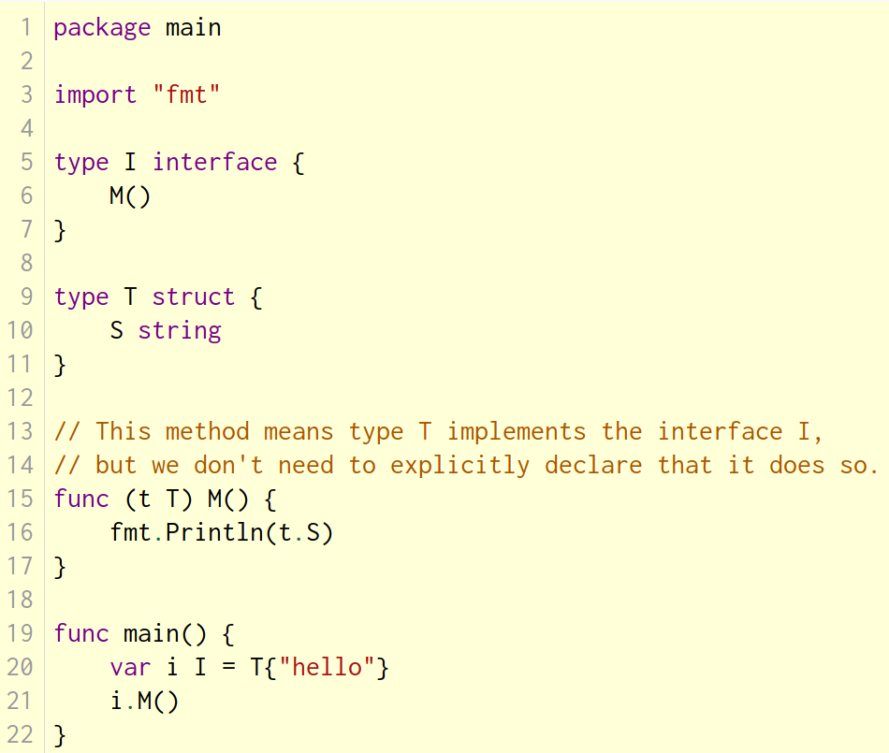
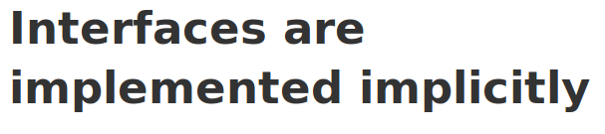
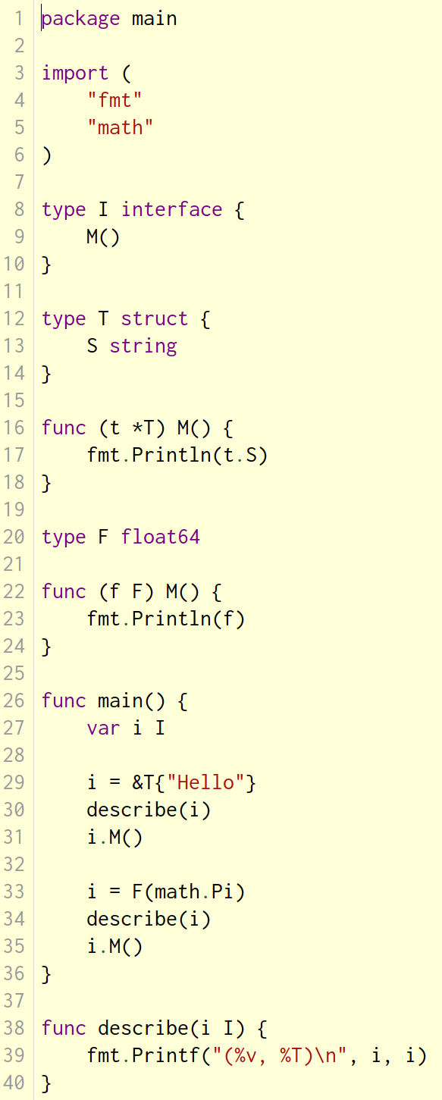

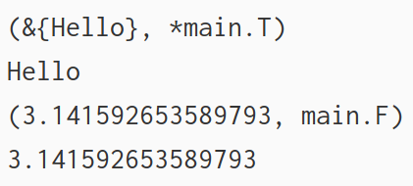

Interface values with nil underlying values
If the concrete value inside the interface itself is nil, the method will be called with a nil receiver.
In some languages this would trigger a null pointer exception, but in Go it is common to write methods that gracefully handle being called with a nil receiver (as with the method M in this example.)
Note that an interface value that holds a nil concrete value is itself non-nil.
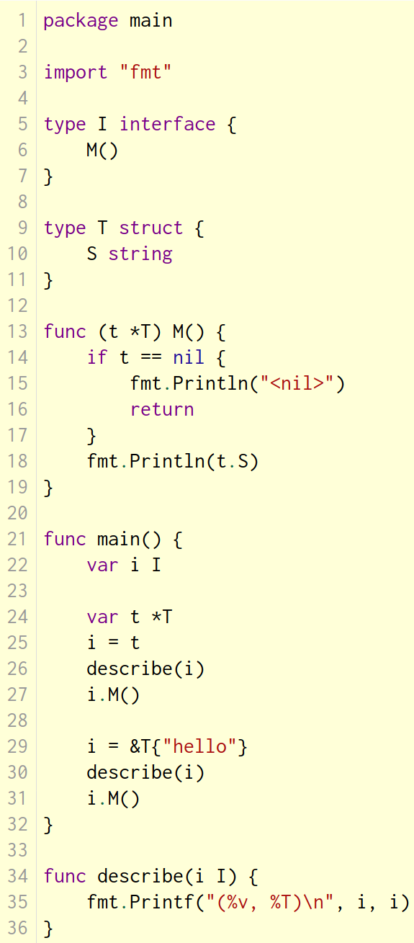
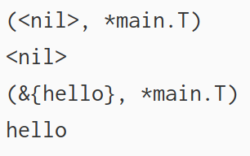

The empty interface
The interface type that specifies zero methods is known as the empty interface:
interface{}
An empty interface may hold values of any type. (Every type implements at least zero methods.)
Empty interfaces are used by code that handles values of unknown type. For example, fmt.Print takes any number of arguments of type interface{}.
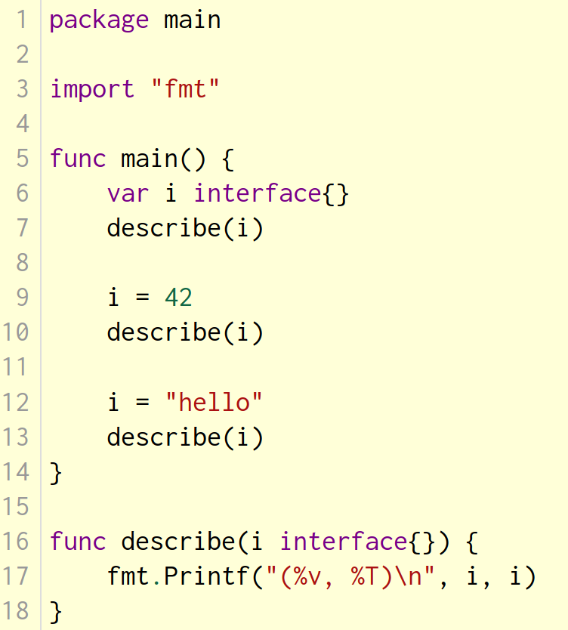
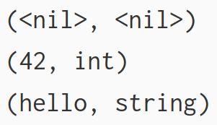

Type assertions
A type assertion provides access to an interface value's underlying concrete value.
t := i.(T)
This statement asserts that the interface value i holds the concrete type T and assigns the underlying T value to the variable t.
If i does not hold a T, the statement will trigger a panic.
To test whether an interface value holds a specific type, a type assertion can return two values: the underlying value and a boolean value that reports whether the assertion succeeded.
t, ok := i.(T)
If i holds a T, then t will be the underlying value and ok will be true.
If not, ok will be false and t will be the zero value of type T, and no panic occurs.
Note the similarity between this syntax and that of reading from a map.
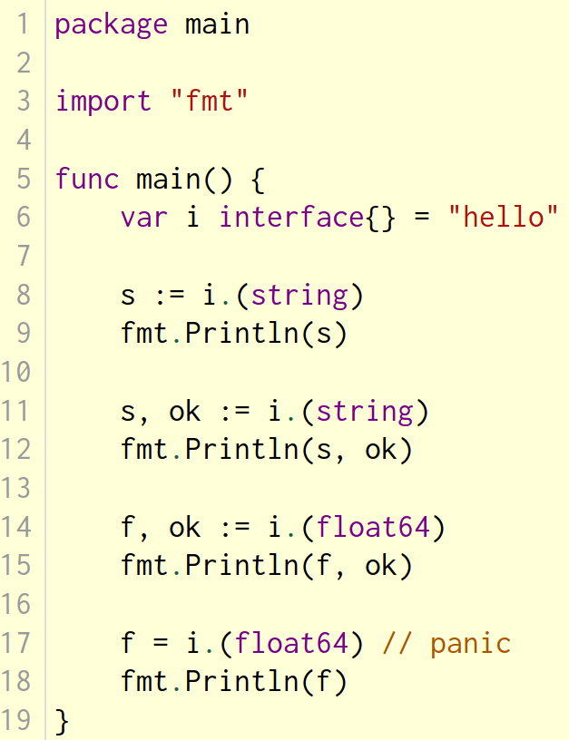
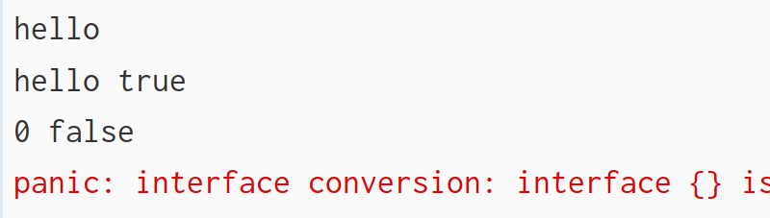

Type switches
A type switch is a construct that permits several type assertions in series.
A type switch is like a regular switch statement, but the cases in a type switch specify types (not values), and those values are compared against the type of the value held by the given interface value.
switch v := i.(type) {
case T:
// here v has type T
case S:
// here v has type S
default:
// no match; here v has the same type as i
}
The declaration in a type switch has the same syntax as a type assertion i.(T), but the specific type T is replaced with the keyword type.
This switch statement tests whether the interface value i holds a value of type T or S. In each of the T and S cases, the variable v will be of type T or S respectively and hold the value held by i. In the default case (where there is no match), the variable v is of the same interface type and value as i.
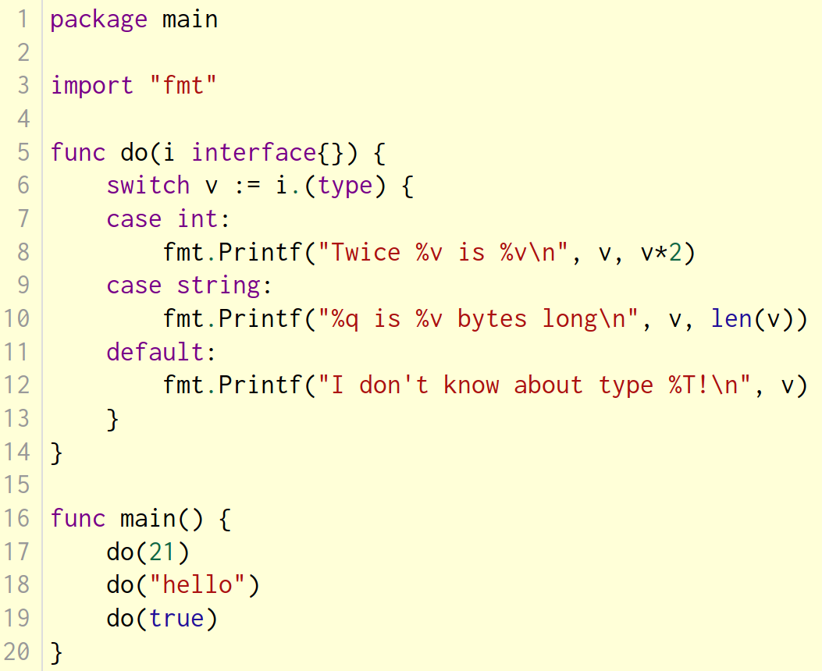
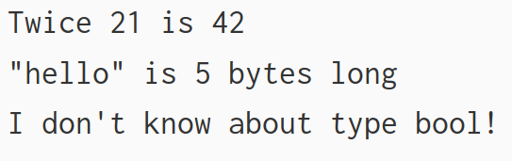
Concurrency

Goroutines

A goroutine is a lightweight thread managed by the Go runtime.
go f(x, y, z)
starts a new goroutine running
f(x, y, z)
The evaluation of f, x, y, and z happens in the current goroutine and the execution of f happens in the new goroutine.
Goroutines run in the same address space, so access to shared memory must be synchronized. The sync package provides useful primitives, although you won't need them much in Go as there are other primitives. (See the next slide.)


